# Kushal Ahuja

# Student Id: 14191922

# Airline Database

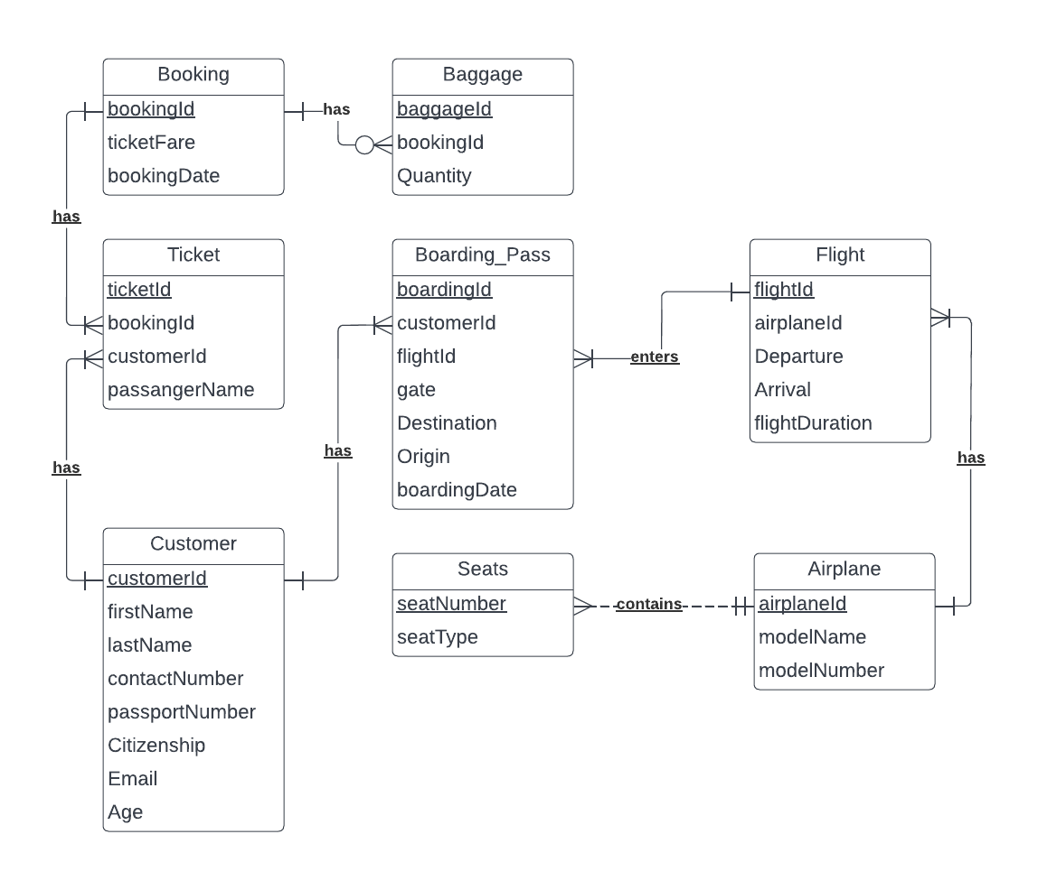

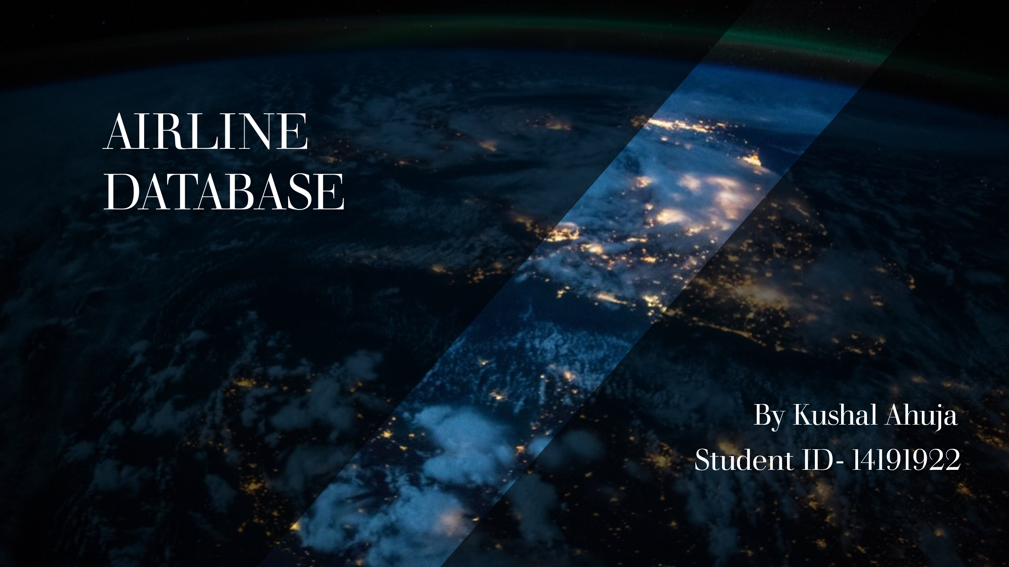

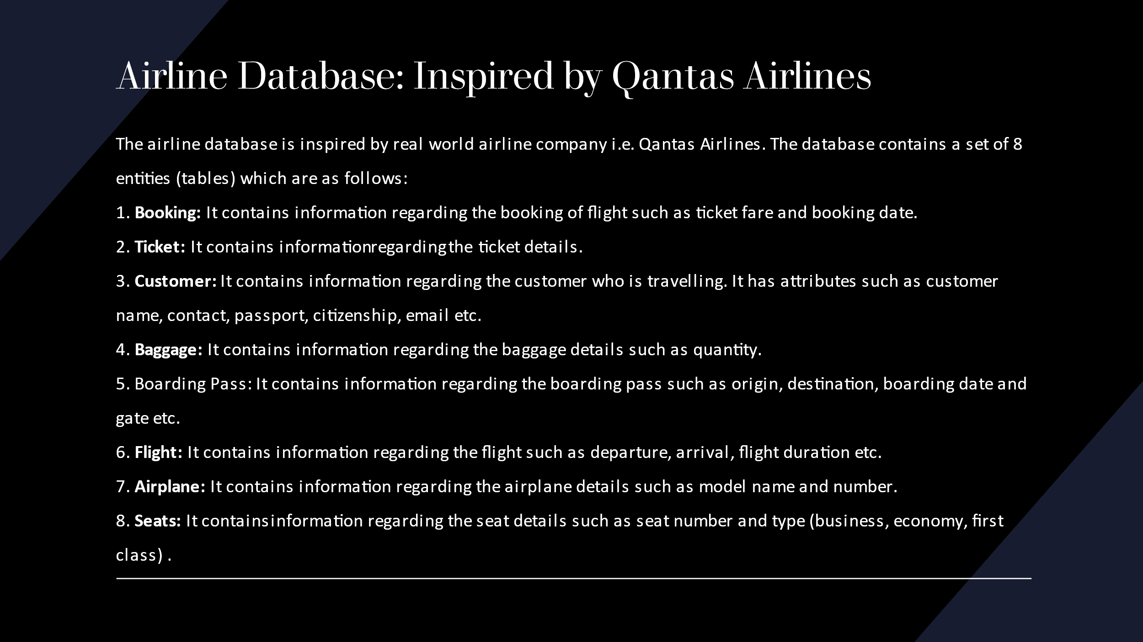

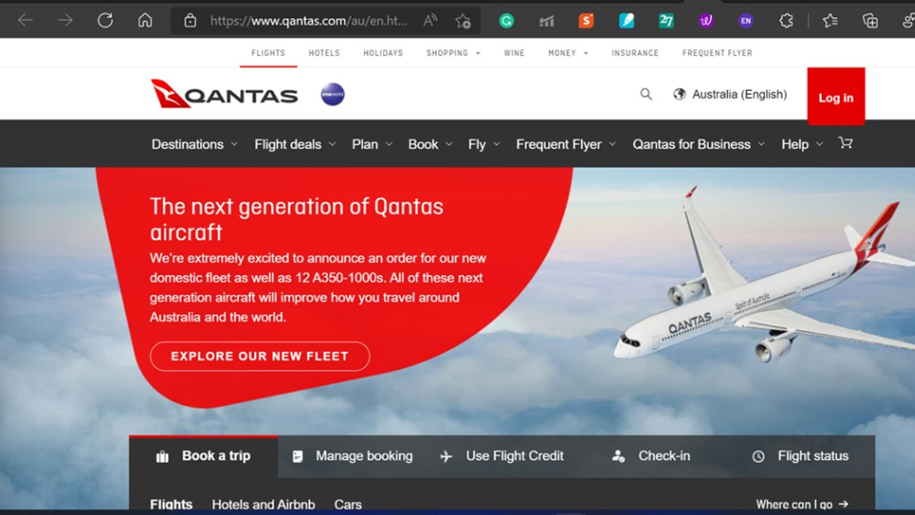

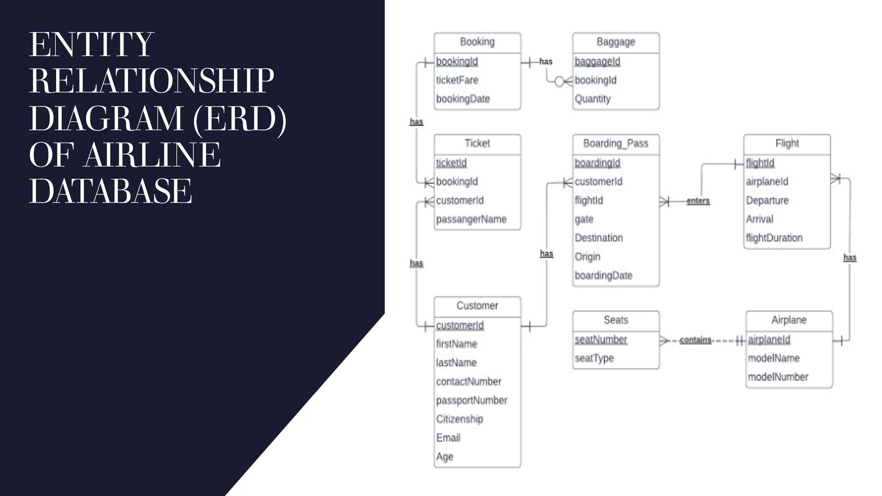

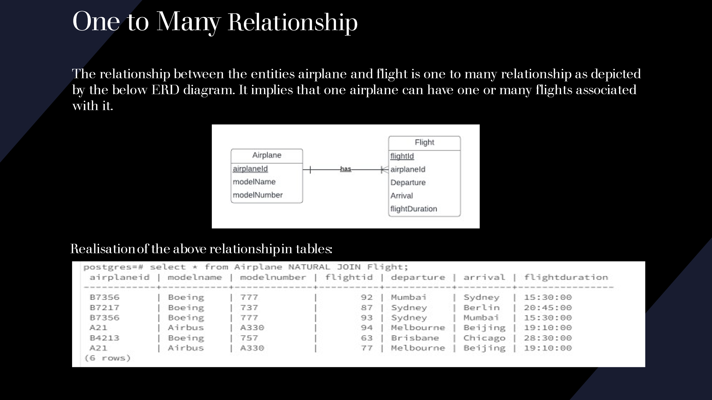

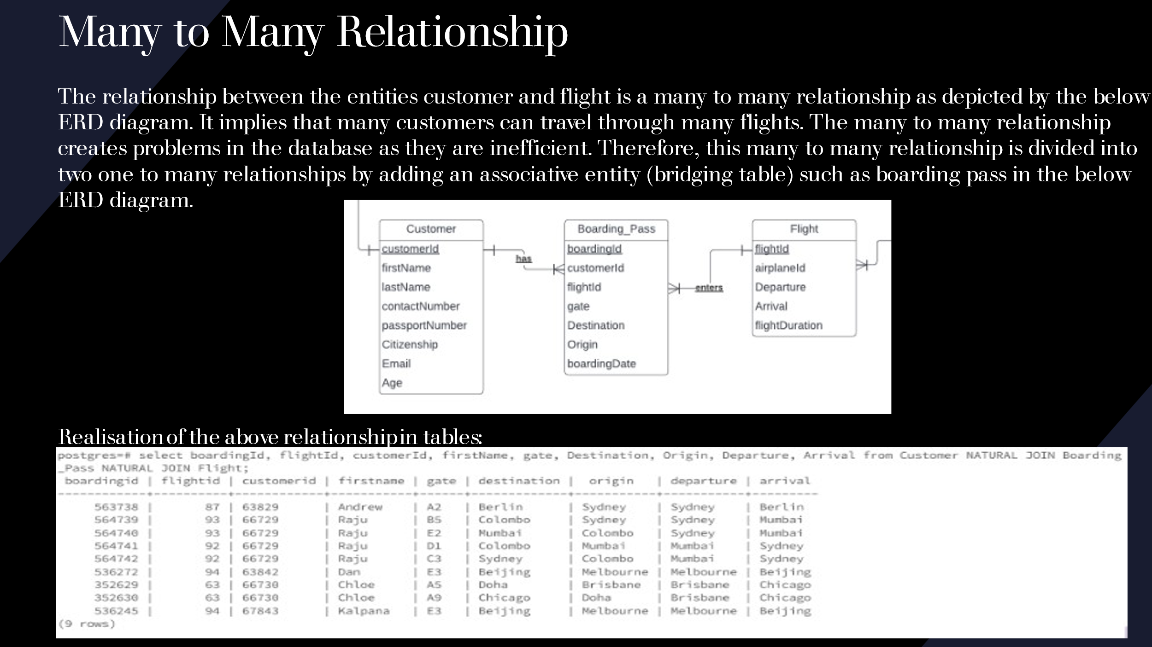

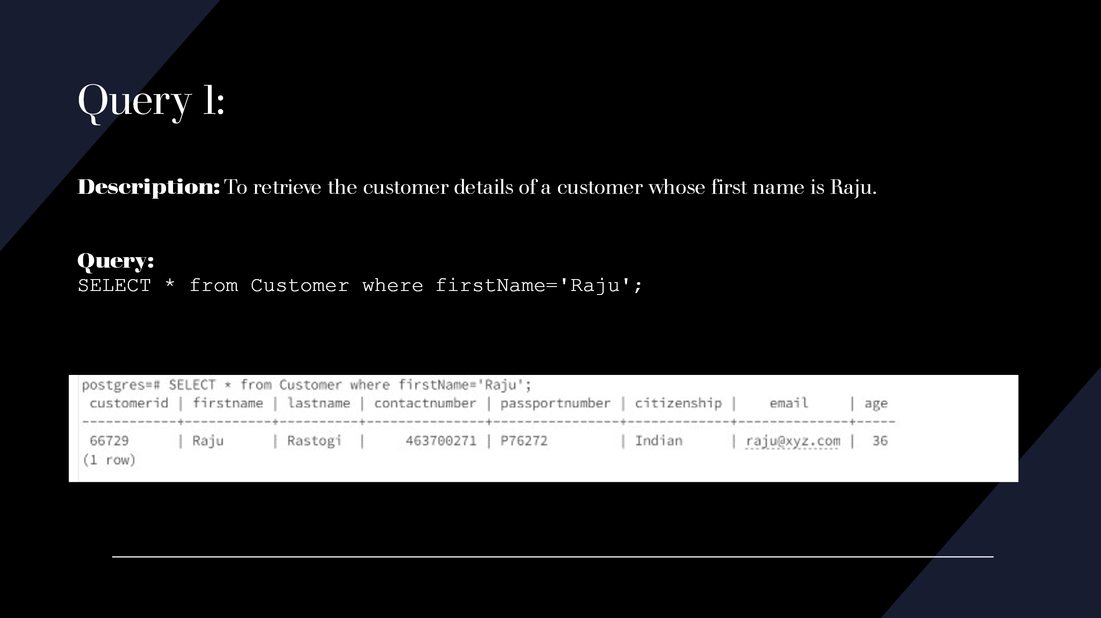

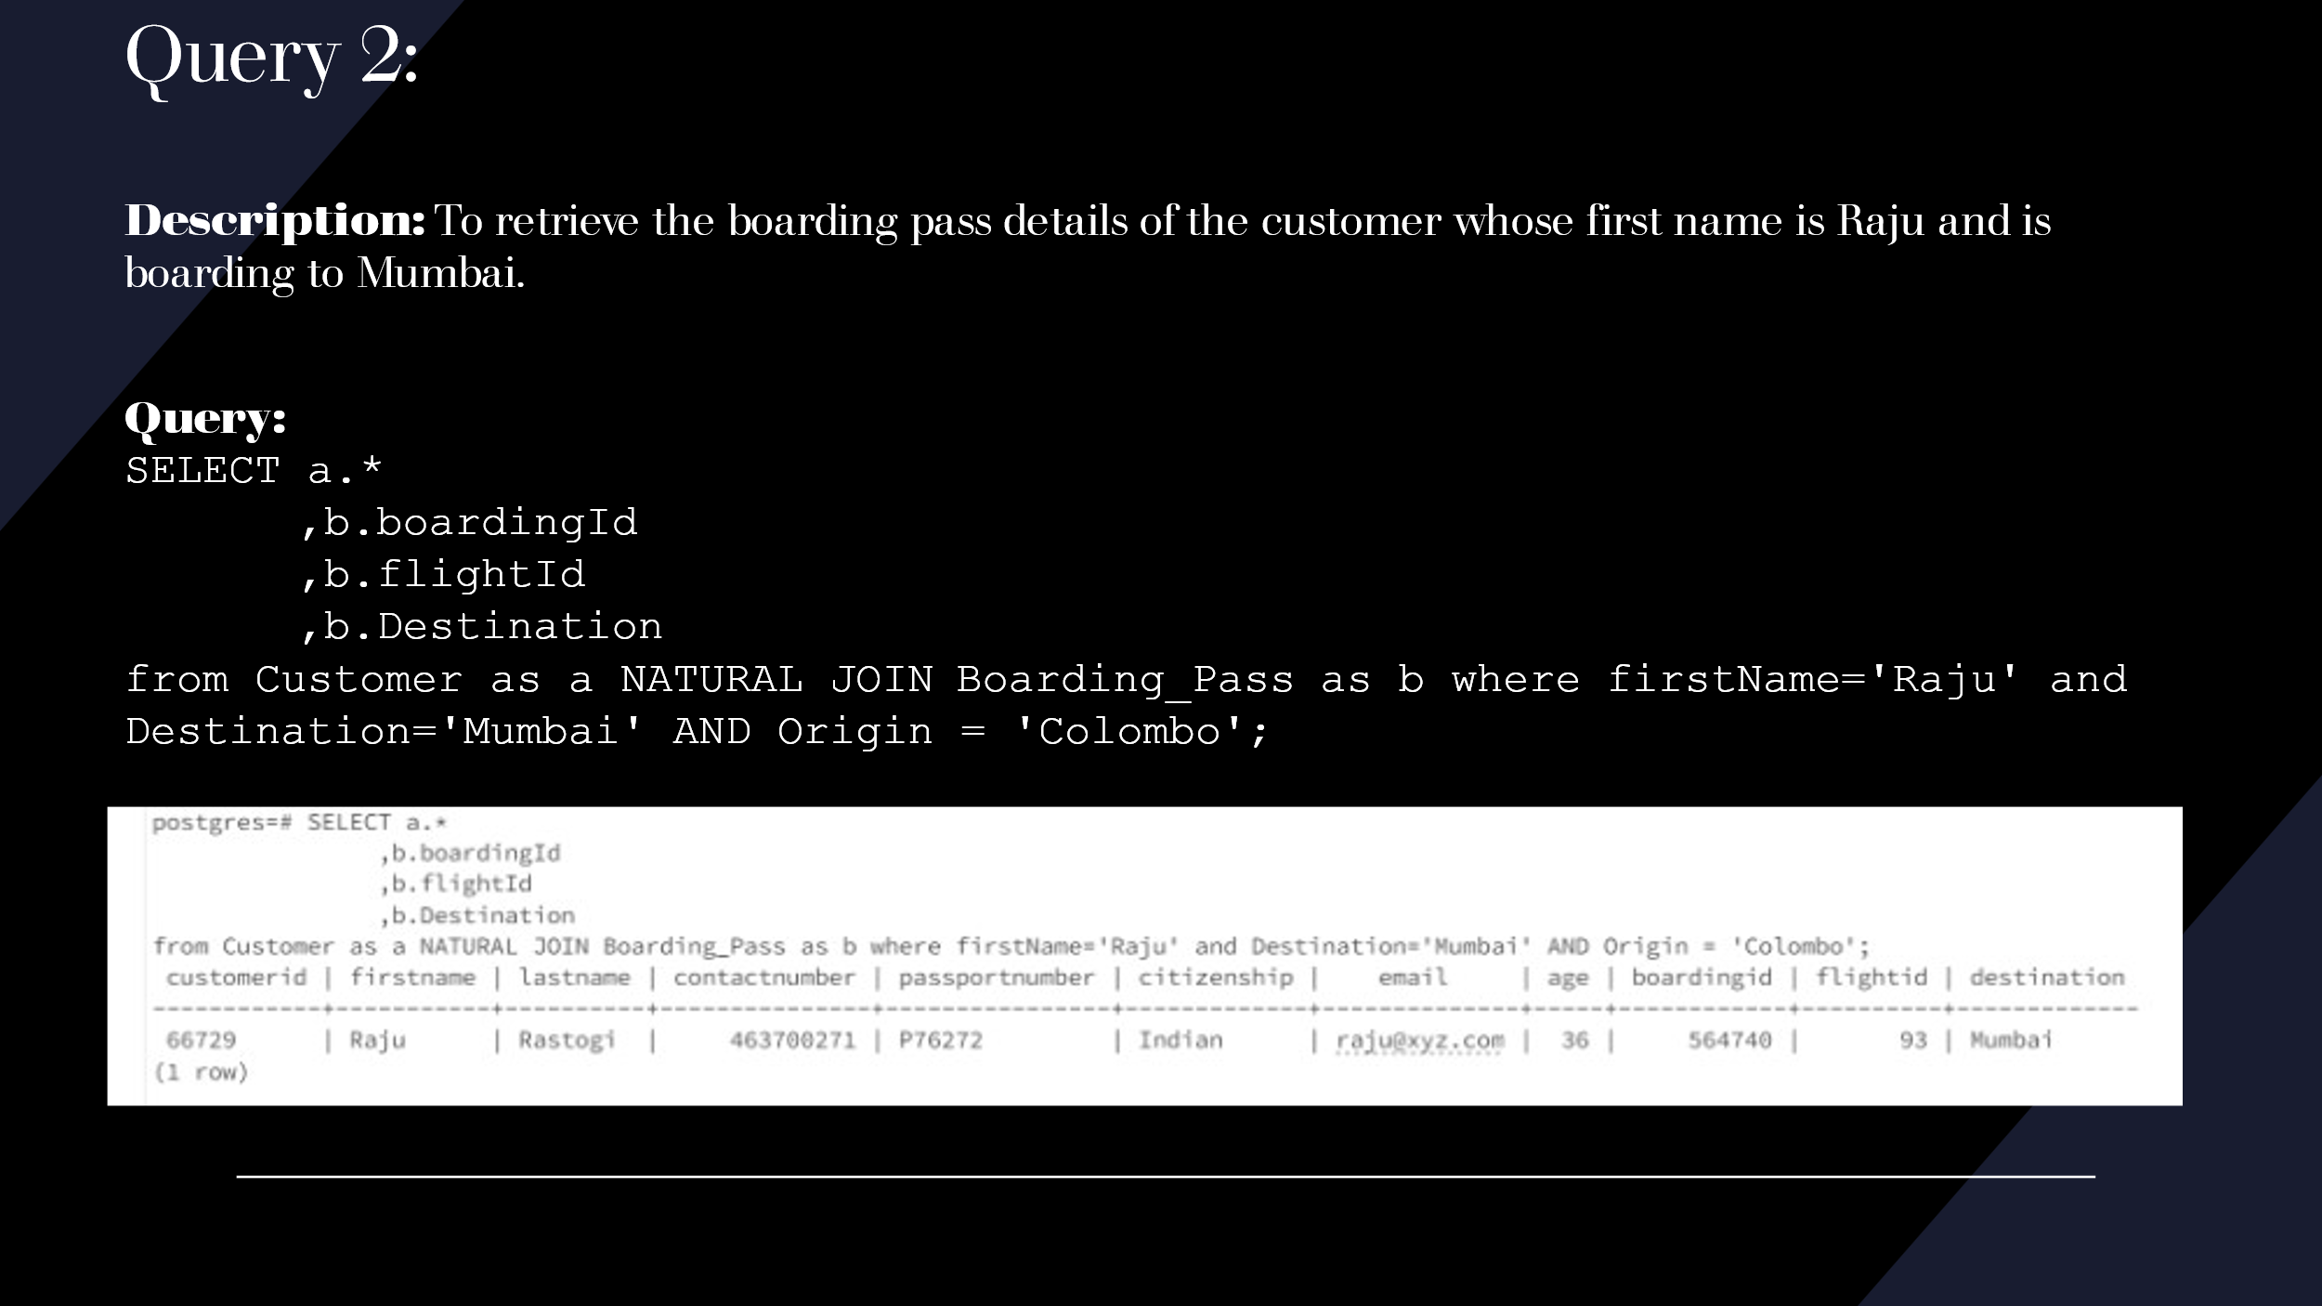

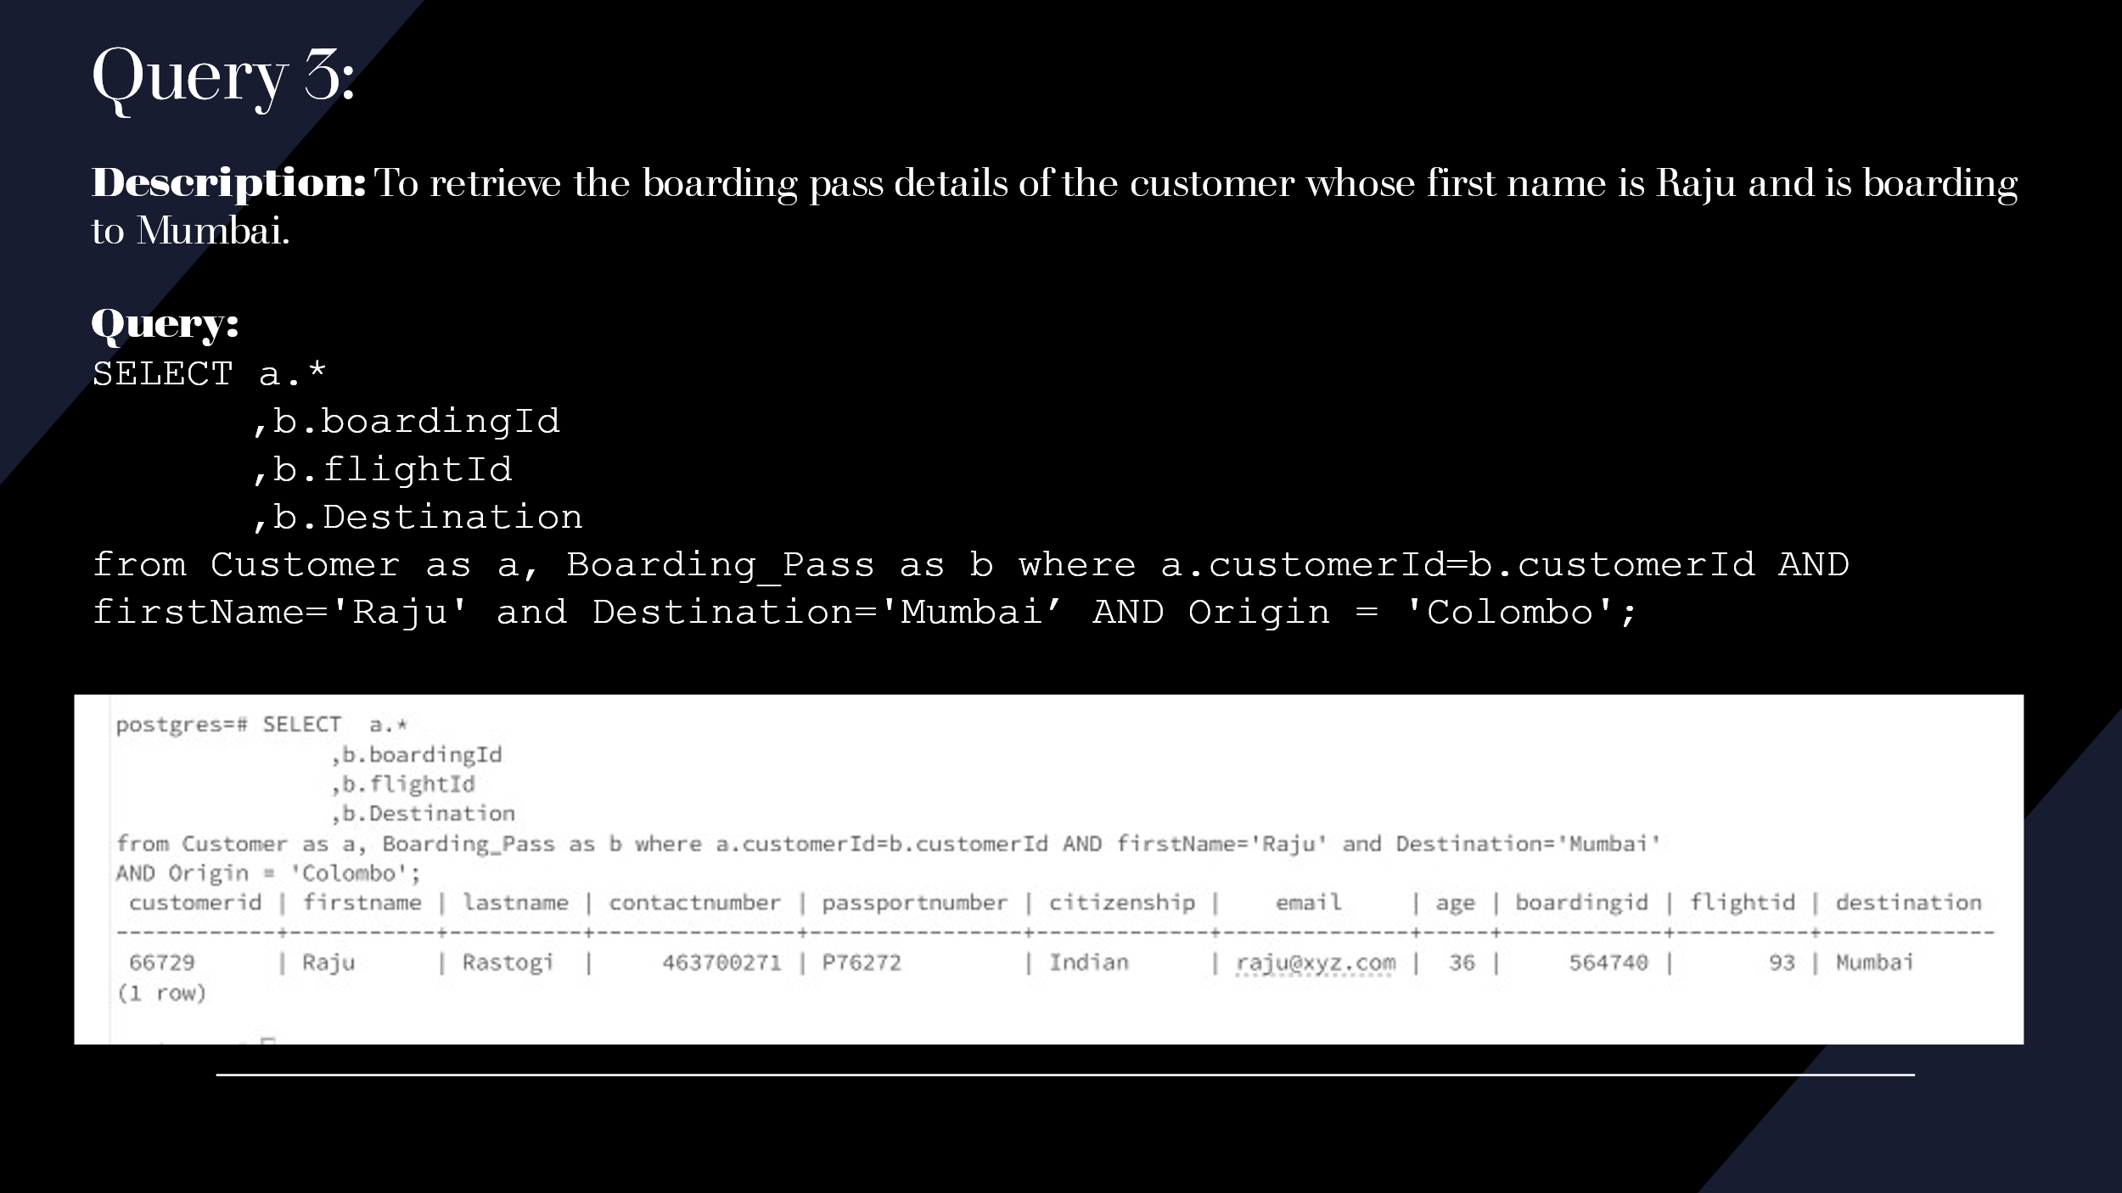

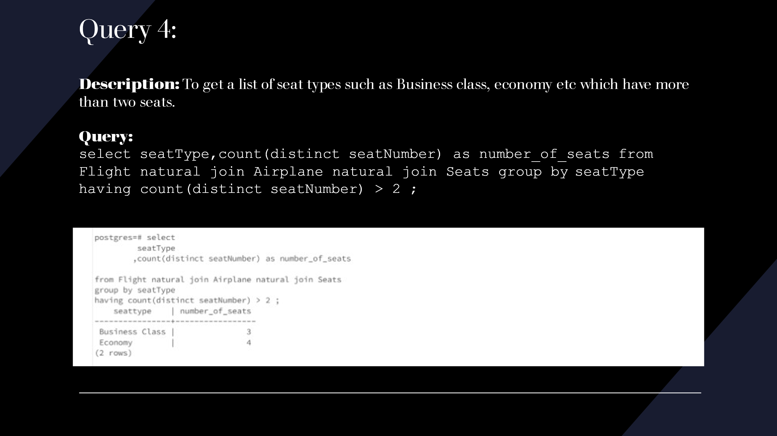

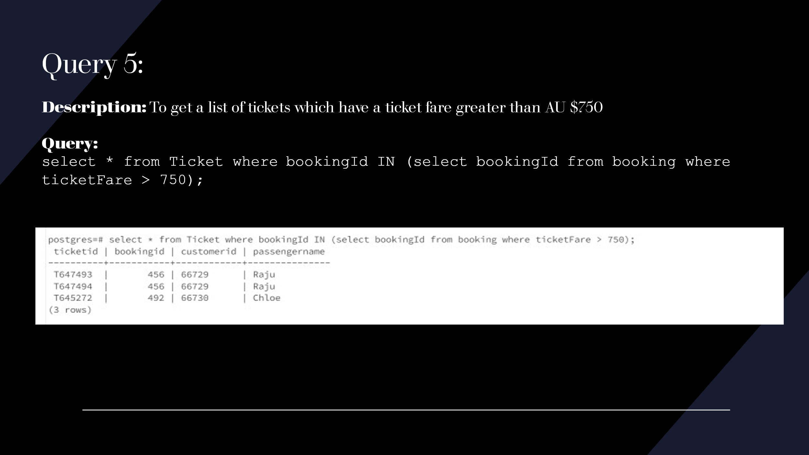

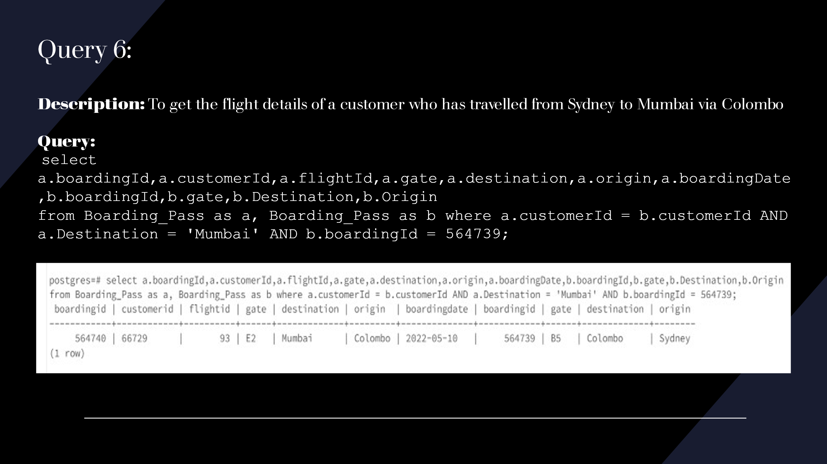

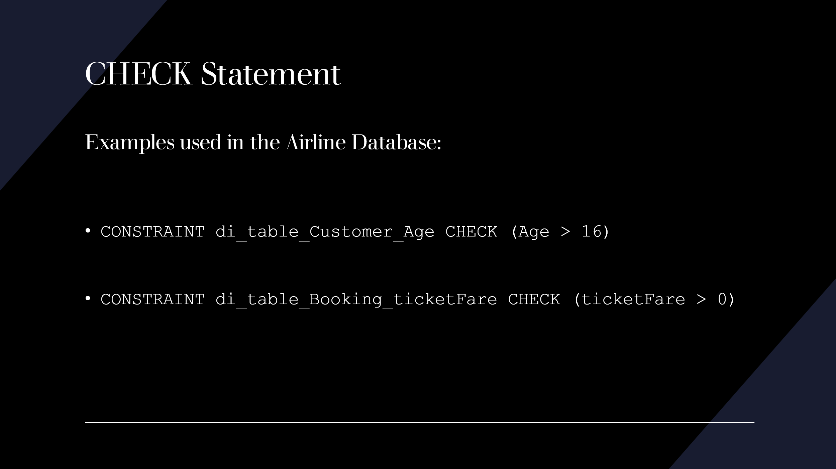

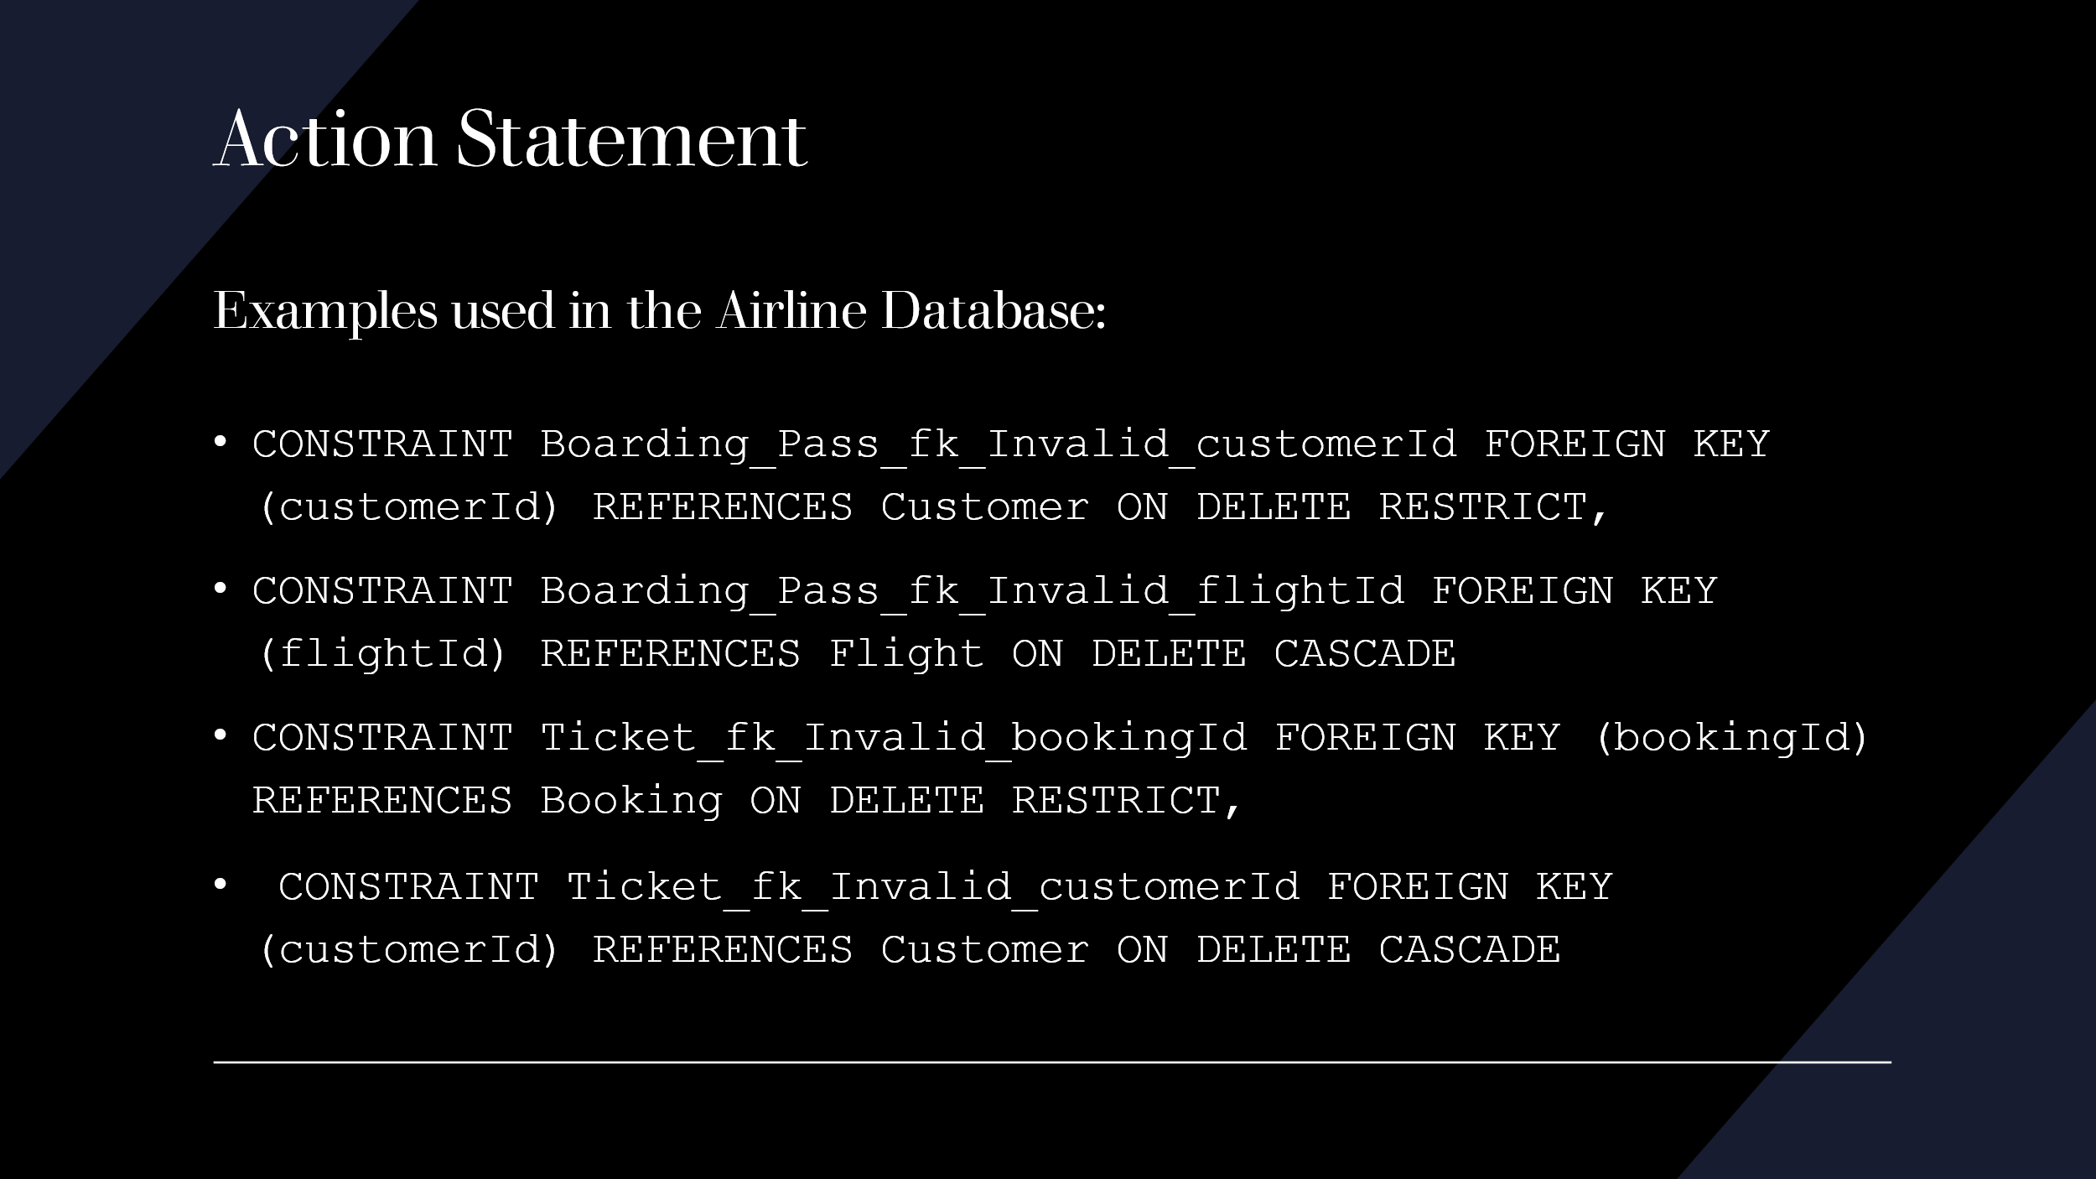

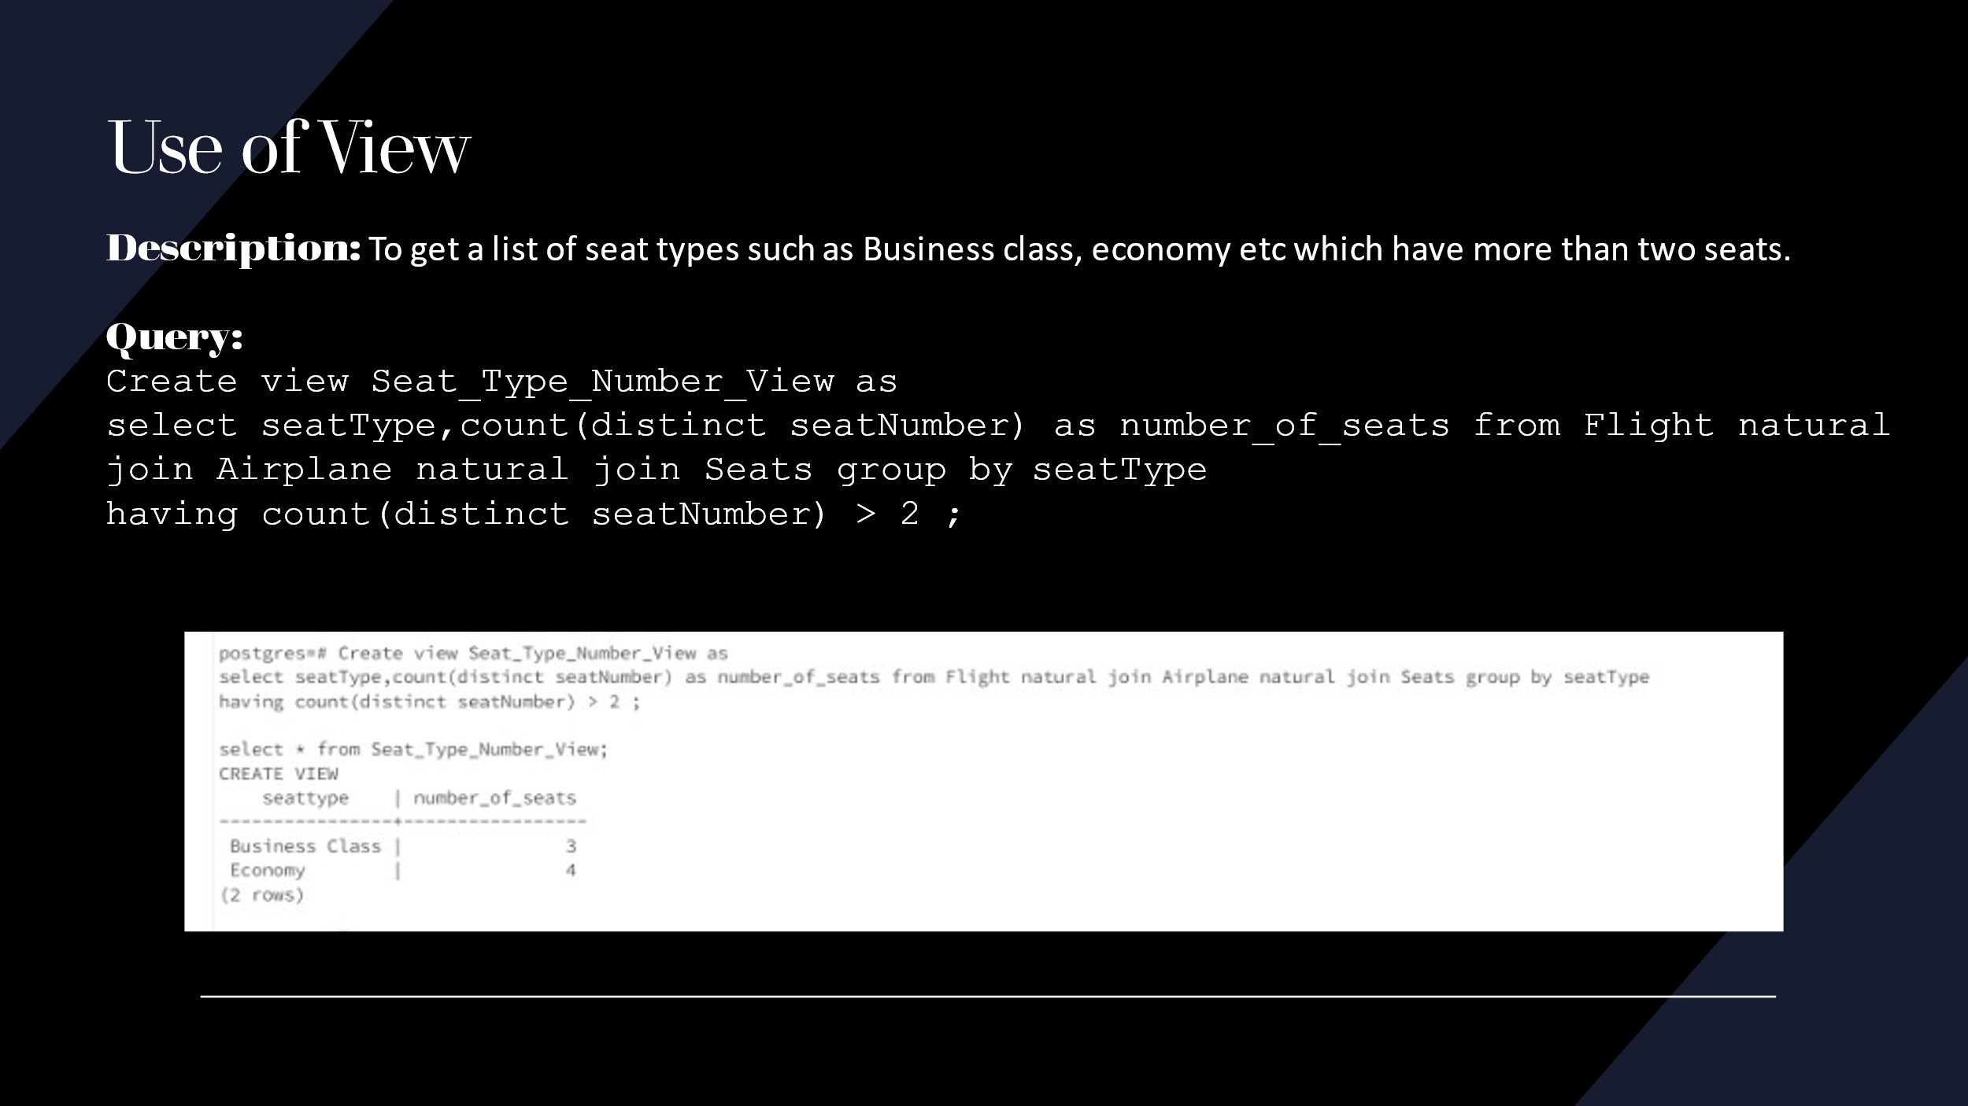

**Creation of Airline Database in SQL**

Drop view Seat_Type_Number_View CASCADE;

Drop table Ticket CASCADE;

Drop table Seats CASCADE;

Drop table Baggage CASCADE;

Drop table Boarding_Pass CASCADE;

Drop table Flight CASCADE;

Drop table Airplane CASCADE;

Drop table Booking CASCADE;

Drop table Customer CASCADE;

CREATE TABLE Customer (

customerId Varchar(20),

firstName Text,

lastName Text,

contactNumber Integer,

passportNumber Varchar(50),

Citizenship Text,

Email Varchar(50),

Age Integer,

CONSTRAINT Customer_pk PRIMARY KEY (customerId),

CONSTRAINT di_table_Customer_Age CHECK (Age > 16)

);

CREATE TABLE Booking (

bookingId Integer,

ticketFare Integer,

bookingDate Date,

CONSTRAINT Booking_pk PRIMARY KEY (bookingId),

CONSTRAINT di_table_Booking_ticketFare CHECK (ticketFare > 0)

);

CREATE TABLE Airplane (

airplaneId Varchar(20),

modelName Text,

modelNumber Varchar(20),

CONSTRAINT Airplane_pk PRIMARY KEY (airplaneId)

);

CREATE TABLE Flight (

flightId Integer,

airplaneId Varchar(20),

Departure Text,

Arrival Text,

flightDuration Interval,

CONSTRAINT Flight_pk PRIMARY KEY (flightId),

CONSTRAINT Flight_fk FOREIGN KEY (airplaneId) REFERENCES Airplane

);

CREATE TABLE Boarding_Pass (

boardingId Integer,

customerId Varchar(20),

flightId Integer,

gate varchar(5),

Destination Text,

Origin Text,

boardingDate Date,

CONSTRAINT Boarding_Pass_pk PRIMARY KEY (boardingId),

CONSTRAINT Boarding_Pass_fk_Invalid_customerId FOREIGN KEY (customerId) REFERENCES Customer ON DELETE RESTRICT,

CONSTRAINT Boarding_Pass_fk_Invalid_flightId FOREIGN KEY (flightId) REFERENCES Flight ON DELETE CASCADE

);

CREATE TABLE Baggage (

baggageId Varchar(20),

bookingId Integer,

Quantity Integer,

CONSTRAINT Baggage_pk PRIMARY KEY (baggageId),

CONSTRAINT Baggage_fk FOREIGN KEY (bookingId) REFERENCES Booking

);

CREATE TABLE Seats (

seatNumber Varchar(5),

seatType Text,

CONSTRAINT Seats_pk PRIMARY KEY (seatNumber)

);

CREATE TABLE Ticket(

ticketId Varchar(20),

bookingId Integer,

customerId Varchar(20),

passengerName Text,

CONSTRAINT Ticket_pk PRIMARY KEY (ticketId),

CONSTRAINT Ticket_fk_Invalid_bookingId FOREIGN KEY (bookingId) REFERENCES Booking ON DELETE RESTRICT,

CONSTRAINT Ticket_fk_Invalid_customerId FOREIGN KEY (customerId) REFERENCES Customer ON DELETE CASCADE

);

Create VIEW Seat_Type_Number_View as

select seatType, count(distinct seatNumber) as number_of_seats

from Flight natural join Airplane natural join Seats

group by seatType

having count(distinct seatNumber) > 2;

Insert Into Customer Values

('63829','Andrew','Roger',448934562,'A73829','Australian','andrew@xyz.com', 23),

('66729','Raju','Rastogi',463700271,'P76272','Indian','raju@xyz.com', 36),

('63842','Dan','Wong',446272961,'A73539','Australian','dan@xyz.com', 49),

('66730','Chloe','Williams',463700272,'A77229','Australian','chloe@xyz.com', 21),

('67843','Kalpana','Modi',456789527,'P70233','Indian','kalpana@xyz.com', 28) ;

Insert INTO BOOKING VALUES

(123,750,'2022-04-22'),

(456,760,'2022-04-22'),

(789,750,'2022-04-23'),

(492,800,'2022-04-25'),

(856,690,'2022-04-26');

Insert into Airplane Values

('B7363','Boeing','777'),

('B7217','Boeing','737'),

('B7356','Boeing','777'),

('A21', 'Airbus', 'A330'),

('B4213','Boeing','757');

Insert into Flight Values

(92,'B7356','Mumbai','Sydney','15 hours 30 minutes'),

(87,'B7217','Sydney','Berlin','20 hours 45 minutes'),

(93,'B7356','Sydney','Mumbai','15 hours 30 minutes'),

(94,'A21','Melbourne','Beijing','19 hours 10 minutes'),

(63,'B4213','Brisbane','Chicago','28 hours 30 minutes'),

(77,'A21','Melbourne','Beijing','19 hours 10 minutes');

Insert into Boarding_Pass Values

(563738,'63829','87','A2','Berlin','Sydney','2022-05-08'),

(564739,'66729','93','B5','Colombo','Sydney','2022-05-10'),

(564740,'66729','93','E2','Mumbai','Colombo','2022-05-10'),

(564741,'66729','92','D1','Colombo','Mumbai','2022-05-25'),

(564742,'66729','92','C3','Sydney','Colombo','2022-05-25'),

(536272,'63842','94','E3','Beijing','Melbourne','2022-05-15'),

(352629,'66730','63','A5','Doha','Brisbane','2022-05-22'),

(352630,'66730','63','A9','Chicago','Doha','2022-05-22'),

(536245,'67843','94','E3','Beijing','Melbourne','2022-05-15');

Insert into Baggage Values

('B73',123,3),

('B32',456,4),

('B56',789,1),

('B23',492,4),

('B77',856,3);

Insert into Seats Values

('30A','Economy'),

('2A','First Class'),

('7B','Business Class'),

('21E','Economy'),

('35C','Economy'),

('1A','First Class'),

('7F','Business Class'),

('10B','Business Class'),

('21A','Economy');

Insert into Ticket Values

('T563769',123,'63829','Andrew'),

('T647493',456,'66729','Raju'),

('T647494',456,'66729','Raju'),

('T643829',789,'63842','Dan'),

('T645272',492,'66730','Chloe'),

('T642527',856,'67843','Kalpana');

**Requested Quries**

**Query 1**

SELECT * from Customer where firstName='Raju';

**Query 2**

SELECT a.*  
 ,b.boardingId  
 ,b.flightId  
 ,b.Destination  
from Customer as a NATURAL JOIN Boarding_Pass as b where firstName='Raju' and Destination='Mumbai' AND Origin = 'Colombo';

**Query 3**

SELECT a.*  
 ,b.boardingId  
 ,b.flightId  
 ,b.Destination  
from Customer as a, Boarding_Pass as b where a.customerId=b.customerId AND firstName='Raju' and Destination='Mumbai’ AND Origin = 'Colombo';

**Query 4**

select seatType,count(distinct seatNumber) as number_of_seats from Flight natural join Airplane natural join Seats group by seatType  
having count(distinct seatNumber) > 2 ;

**Query 5**

select * from Ticket where bookingId IN (select bookingId from booking where ticketFare > 750);

**Query 6**

select a.boardingId,a.customerId,a.flightId,a.gate,a.destination,a.origin,a.boardingDate,b.boardingId,b.gate,b.Destination,b.Origin   
from Boarding_Pass as a, Boarding_Pass as b where a.customerId = b.customerId AND a.Destination = 'Mumbai' AND b.boardingId = 564739;